ME 7120: Project 1

Finite Element Method Applications

Due: October 28, 2016

Team Members:

Philip Bear

Michelle Callaham

Hao Li

# Project Introduction

This project allowed us to compare finite element submodules using two different software programs. Using the WFEM code in MATLAB, we wrote a general element code which generated the elemental stiffness and mass matrices for each element. This code also returned the coordinate transformation matrix, the FE matrices in global coordinates, and we assembled the elements into a global matrix. Next, we compared the results using ANSYS. In ANSYS, we constructed the model with the geometry, material properties, and number of elements. We were able to produce the deflection results, nodal degrees of freedom table, and do a convergence study. For this project, we performed this analysis on a simple and a complex problem. For the simple problem, we performed analysis on a simple cantilever beam. We then used a linearly tapered beam element for our complex example.

# Finite Element Submodules

## Simple Cantilever Beam Example

To begin this problem, we had to define the simple cantilever beam. We clamped the beam at the left end and put a tip load as a loading condition on the right end of the beam as shown in Figure 1.

[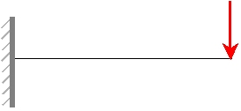](https://www.google.com/url?sa=i&rct=j&q=&esrc=s&source=images&cd=&cad=rja&uact=8&ved=0ahUKEwjsyd3sn_zPAhXE7yYKHZOOAYoQjRwIBw&url=http://www.diracdelta.co.uk/science/source/c/a/cantilever%20beam/source.html&psig=AFQjCNHyRiYgEzaXS9MjdlYGEYJ7qmINaw&ust=1477701130296218)

Figure 1: Simple Cantilever Beam

We split the beam into 10 evenly spaced elements. We defined the following beam geometry and material properties, which is based on the steel material that was predefined in WFEM.

*Beam Geometry: $Uniform Square Cross Section:t=0.02$*

$$Beam Length:l=25$$

*Material Properties: $Young^{'}s Modulus:E=2.0340e11$*

$$Shear Modulus:G=7.8835e10$$

$$Density:7850$$

Using the WFEM program, we determined the deflection and rotation at the tip. The tip deflection was -1.9204 and the tip rotation was -0.1152. Figure 2 below shows the deflection of the beam when the load is applied.

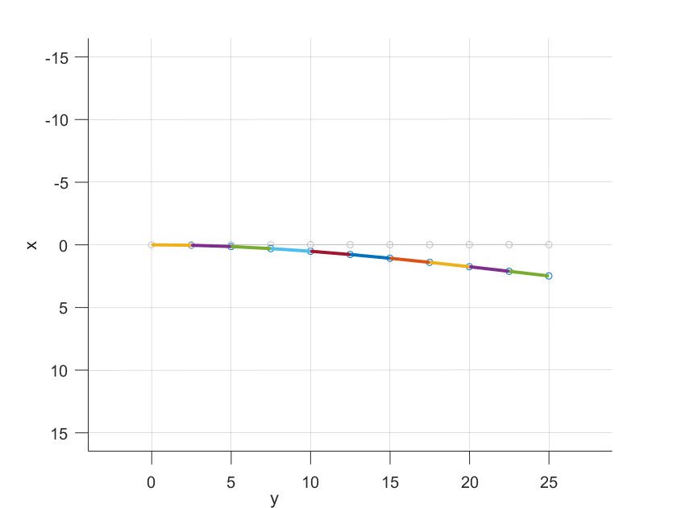

Figure 2: Deflection of Cantilever Beam using WFEM

Next, we used ANSYS to compare our results for the deflection and rotation of the simple cantilever beam. Using this analysis method, the tip deflection had a result of -1.9166 and a rotation of -0.11523. Figure 3 shows the results of the deflection of the simple cantilever beam using the ANSYS software. Additional information regarding the results of this problem can be found in the Appendix.

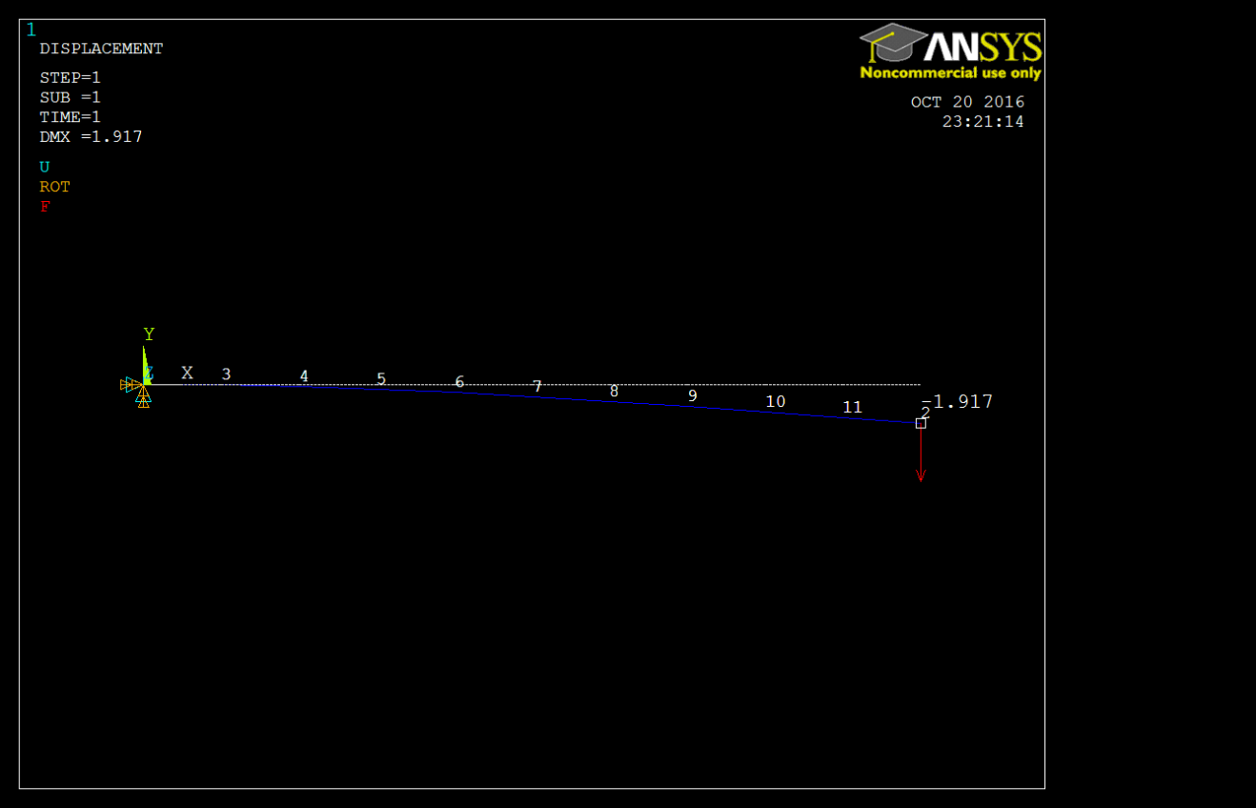

Figure 3: Deflection of Cantilever Beam using ANSYS

We did a convergence test in ANSYS using 11 nodes for the same cantilever problem. The tip deflection and rotation have the same value as when we used 10 elements. This proves it is convergent. Figure 4 below shows the beam deflection when 11 nodal elements are applied. Additional results for this problem are included in the appendix.

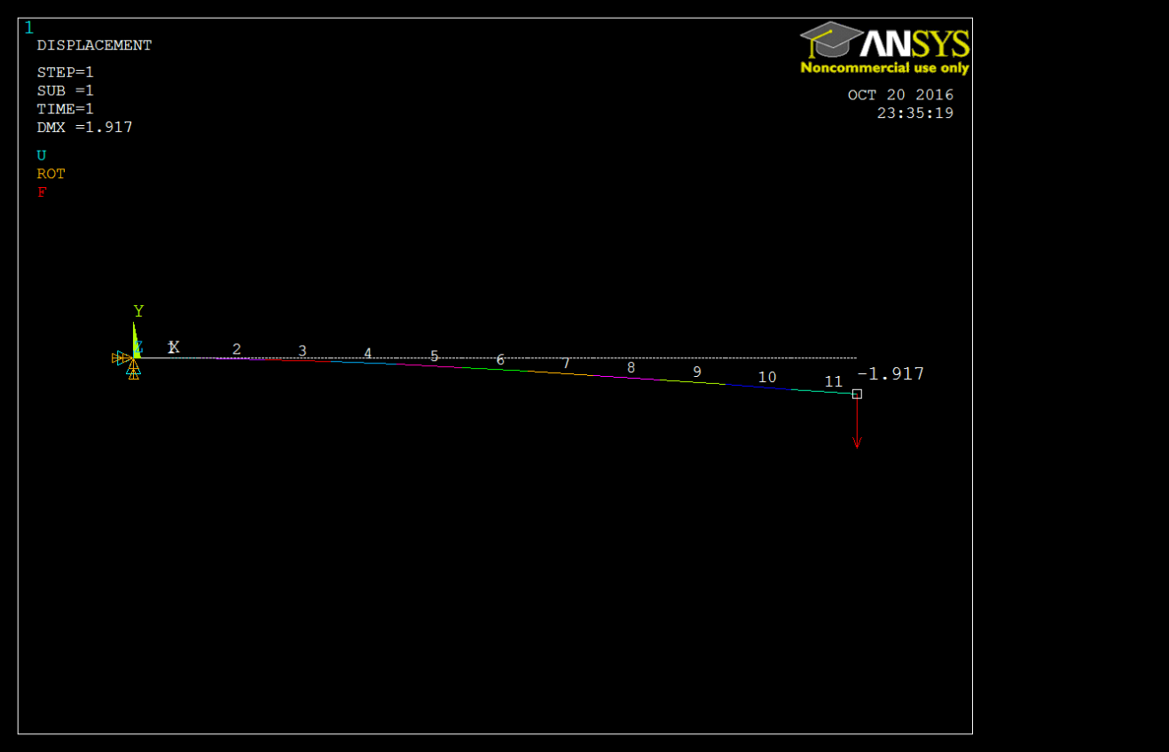

Figure 4: Convergence Test for Deflection of Cantilever Beam in ANSYS

We are now able to compare the values for the tip deflection and tip rotation from the WEFM, ANSYS results and analytical solution. Table 1 below shows the values and the difference shown as a percentage. As it shows, the WFEM solution matches the analytical solution, while the ANSYS solutions have 0.203% and 0.026% difference for tip deflection and tip rotation, respectively. The values we received were very close together and we could accept either method. It shows that either method produces accurate results since there is a very small difference between the results from each method. The analytical calculation is shown in the appendix.

|  |  |  |  |  |  |
| --- | --- | --- | --- | --- | --- |
|  | Analytical | WFEM | Difference | ANSYS | Difference |
| Tip Deflection | 1.9205 | 1.9205 | 0 | 1.9166 | 0.203% |
| Tip Rotation | 0.1152 | 0.1152 | 0 | 0.11523 | 0.026% |

Table 1: Simple Cantilever Beam Result Comparison

## Linearly Tapered Beam Example

Our more complex example is a linearly tapered beam element. The left end of the beam is clamped and there is a loading condition on the right end of the beam. We defined the following beam geometry and material properties, which is based on the steel material that was predefined in WFEM. An illustration of our tapered beam element is shown below in

t1

t2

P

Figure 5: Linearly Tapered Beam Element

*Beam Geometry: $Tapered Square Cross Section:t1=0.1$*

$$Tapered Square Cross Section:t1=0.02$$

$$Beam Length:l=25$$

*Material Properties: $Young^{'}s Modulus:E=2.0340e11$*

$$Shear Modulus:G=7.8835e10$$

$$Density:7850$$

First, we studied this model using ANSYS to study the convergence and find the ideal number of nodes to use which would result in the smallest change of deflection between the nodal elements. Table 2 shows the convergence test showing the number of elements and the resulting tip deflection.

|  |  |  |
| --- | --- | --- |
| Number of Elements | Tip Deflection | Difference |
| 5 | 0.01601 |  |
| 6 | 0.01579 | 1.386% |
| 7 | 0.01566 | 0.836% |
| 8 | 0.01558 | 0.524% |

Table 2: Convergence Test

Since there is a very small change when 8 nodal elements are used, we decided to use 8 elements for the analysis of this problem. Figure 6 below shows the deflection of the tapered beam when the load is applied to the right tip.

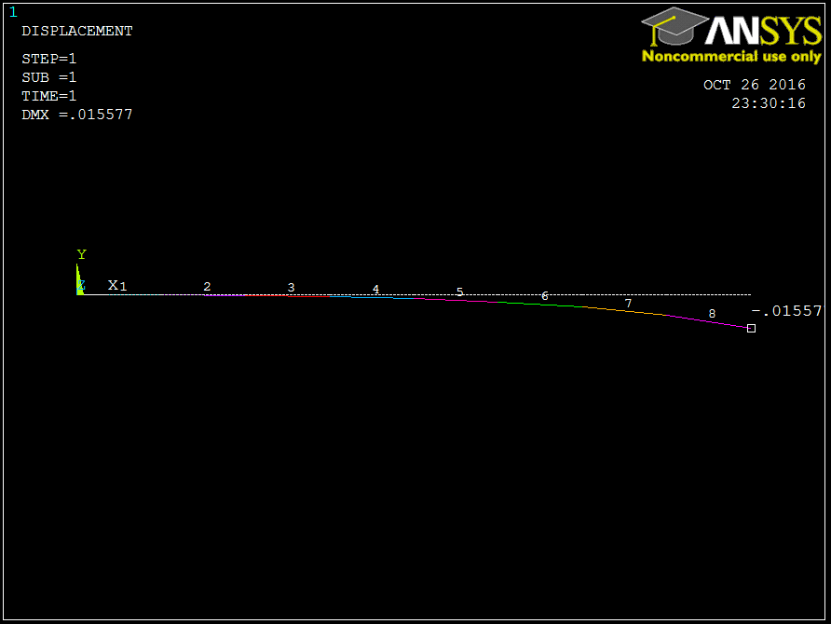

Figure 6: Deflection of Linearly Tapered Beam Element in ANSYS

We used the WFEM code to calculate the deflection of the linear tapered beam using this method. The tip deflection had a value of 0.0147 when use used this MATLAB code to solve the problem. Figure 7 and Figure 8 are plots showing the deflection of the tip when the load is applied.

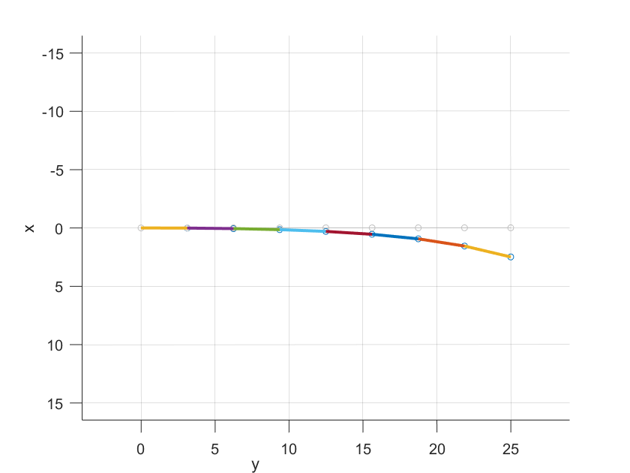

Figure 7: Deflection of Linearly Tapered Beam Element (2D)



Figure 8: Deflection of Linearly Tapered Beam Element (3D)

We are now able to compare the values for the tip deflection found from the WEFM and ANSYS results. Table 3 below shows the values and the difference shown as a percentage. The values we received were close together. They had about a 5.63% difference in the results of the tip deflection. For most applications, either of these methods would be acceptable for finding the tip deflection. If a more precise answer is desired, more nodal points could be used for further analysis of the element.

|  |  |
| --- | --- |
|  | Tip Deflection |
| ANSYS | 0.01558 |
| WFEM | 0.0147 |
| Difference | 5.63% |

Table 3: Tip Deflection Comparison

# Conclusion

This project allowed us to use two different methods of solving a finite element model. Both methods used, ANSYS and MATLAB, produced accurate results and were within a very small difference from one another. We also learned the importance of convergence when analyzing a problem. The number of nodal points improves the accuracy and decreases the percent of error of the resulting deflection. For our simple cantilever beam, the margin there was a very small amount of difference for the deflection and rotation solved using both methods. The more complex problem, the linearly tapered beam, had a higher percentage of difference between the deflections, but they could still be accepted values in industry.

# Appendix

1. **Simple Cantilever Beam Example**
2. Analytical solution
$$y_{tip}=-\frac{PL^{3}}{3EI}=-1.9205$$

$$θ_{tip}=-\frac{PL^{2}}{2EI}=-0.1152$$

3. WFEM input files

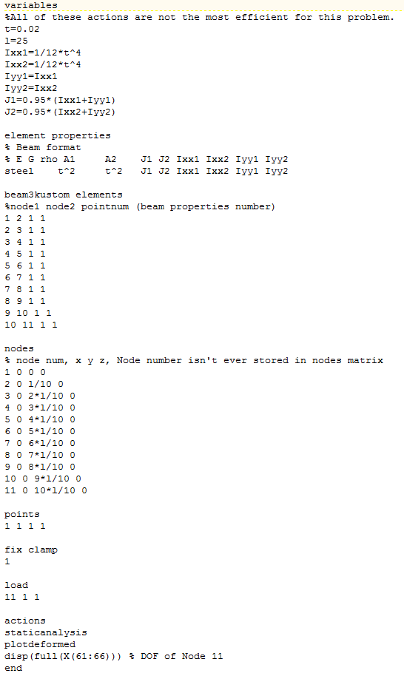

1. ANSYS Results

Nodal Degrees of Freedom (10 Elements)

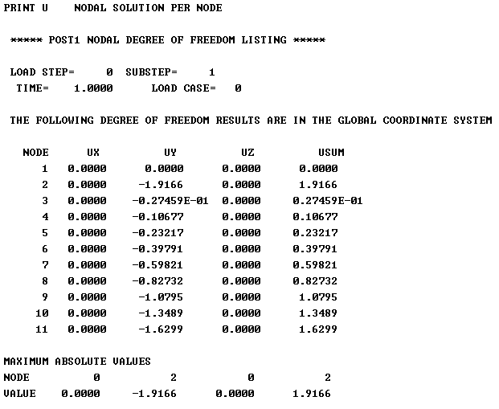

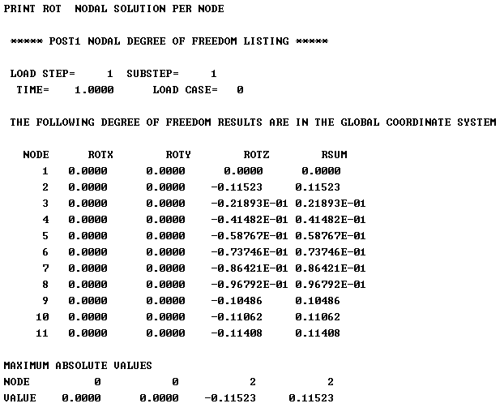

ANSYS Results – Nodal Degrees of Freedom (11 Elements)

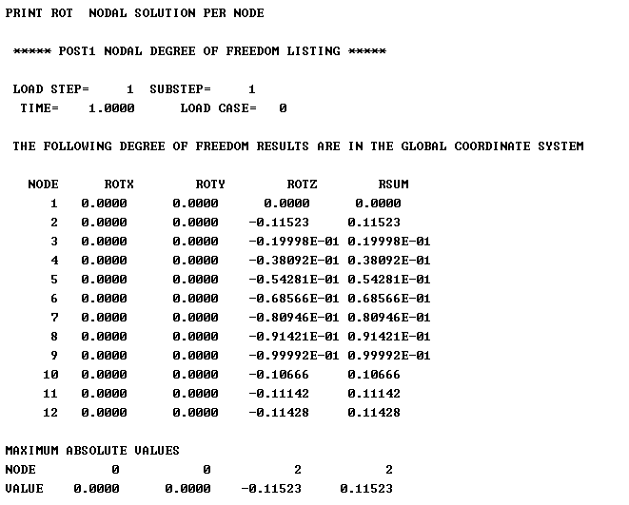

1. **Tapered Cantilever Beam Example**
2. WFEM input file

